
IMPLEMENTATION OF A VIDEO CONFERENCE SCHEDULING MANAGEMENT SYSTEM: A CASE STUDY OF VIDEOLINK ENTERPRISE, NAKURU
SYSTEM DOCUMENTATION
SUBMITTED BY:
GITHINJI VIVIAN
DIT-01-0364/2025
A SYSTEM DOCUMENTATION SUBMITTED IN PARTIAL FULFILMENT FOR THE AWARD OF DIPLOMA IN INFORMATION TECHNOLOGY BY ZETECH UNIVERSITY
NOVEMBER 2026

DECLARATION
I GITHINJI VIVIAN (Reg. No. DIT-01-0364/2025) do declare that this is my original work, and it has never been submitted elsewhere for any academic award.

Student Name: GITHINJI VIVIAN
Sign: _________________________ Date: _________________
Supervisor Name: Madam Esther
Sign: _________________________ Date: _________________
DEDICATION
This project is dedicated to my family for their constant support, encouragement and understanding throughout my academic journey. Their motivation and belief in my abilities gave me the strength to complete this project successfully.
This project is also dedicated to all students pursuing knowledge and innovation in the field of information technology.
ABSTRACT
Organizing virtual meetings becomes difficult when schedules are managed through separate emails, phone calls, messaging applications and written records. At VideoLink Enterprise in Nakuru, this approach makes it hard to keep one reliable view of meeting dates, times and participant availability. The result is overlapping bookings, missed updates and time wasted on checking availability and correcting errors.
This project set out to design and implement a web-based Video Conference Scheduling Management System that centralizes meeting scheduling and improves coordination among participants. The system allows authorized users to log in, create, view, update and cancel meetings, record meeting details and participants in a central database, detect scheduling conflicts automatically before a meeting is saved, and receive in-system notifications and reminders. Access is controlled through three roles: administrator, meeting organizer and participant.
The system was developed using HTML, CSS and JavaScript for the interface, PHP for the application logic and MySQL for the database, with XAMPP as the local development environment. The work followed a structured approach of requirements analysis, design and modelling, implementation, testing and deployment. The models produced include user interface designs, flowcharts, a data flow diagram, an entity relationship diagram, a use case diagram and a class diagram. The system is expected to reduce scheduling errors, save organizers' time and give all participants one accurate source of meeting information. This documentation is presented in four chapters: project planning and analysis, design and modelling, system implementation, and conclusion and recommendations.
DEFINITION OF KEY TERMS
Authentication: The process of verifying a user's identity, usually by checking a username or email address and password against stored records.
Centralized system: A system in which all data is stored and managed in one place so that every authorized user sees the same, up-to-date information.
Conflict detection: An automatic check that identifies when a proposed meeting overlaps in time with another meeting involving the same organizer or participant.
Dashboard: The main screen shown after login, which summarizes important information such as today's meetings, upcoming meetings and unread notifications.
Database: An organized collection of data stored electronically so that it can be easily accessed, managed and updated.
Meeting organizer: The user who creates a meeting, sets its date and time, invites participants and manages the meeting.
Notification: A message displayed within the system to inform users about invitations, schedule changes, cancellations, reminders or detected conflicts.
Participant: A person invited to attend a meeting.
Role-based access control: A security approach in which what a user can see and do in the system depends on the role assigned to them.
Scheduling: The process of deciding and recording when a meeting will take place and who will attend.
Session: The period during which a logged-in user is recognized by the system until they log out or the session expires.
Video conference: A live audio and video meeting held over the internet between people who are in different locations.
Web application: A program that runs on a web server and is used through a web browser, without installing software on the user's computer.
ABBREVIATIONS AND ACRONYMS
CRUD Create, Read, Update, Delete
CSS Cascading Style Sheets
DFD Data Flow Diagram
DIT Diploma in Information Technology
ERD Entity Relationship Diagram
FTP File Transfer Protocol
HTML HyperText Markup Language
HTTPS HyperText Transfer Protocol Secure
IDE Integrated Development Environment
JS JavaScript
Ksh Kenya Shillings
PDO PHP Data Objects
PHP PHP: Hypertext Preprocessor
SQL Structured Query Language
UI User Interface
UML Unified Modelling Language
URL Uniform Resource Locator
XAMPP Cross-platform, Apache, MySQL, PHP and Perl
TABLE OF CONTENTS
DECLARATION ii
DEDICATION iii
ABSTRACT iv
DEFINITION OF KEY TERMS v
ABBREVIATIONS AND ACRONYMS vi
TABLE OF CONTENTS vii
LIST OF FIGURES ix
LIST OF TABLES x
CHAPTER ONE: PROJECT PLANNING AND ANALYSIS 1
1.1 Statement of Problem 1
1.2 STUDY JUSTIFICATION 1
1.3 RESEARCH OBJECTIVES 2
1.3.1 General Objective 2
1.3.2 Specific Objectives 2
1.4. Functional Requirements 2
1.5. Breakdown of Tools & Resources to Be Used 3
1.6 Project Schedule Breakdown 5
CHAPTER TWO: DESIGN AND MODELLING 7
2.1 Introduction to Modelling 7
2.2 User Interface Models 7
2.2.1 Login Page 7
2.2.2 Dashboard 8
2.2.3 Meeting Scheduling Form 9
2.2.4 Meetings and Notifications 10
2.3 Logic Models 10
2.3.1 Login Process Flowchart 11
2.3.2 System Flowchart 12
2.3.3 Data Flow Diagram 13
2.3.4 Entity Relationship Diagram 14
2.3.5 Use Case Diagram 15
2.3.6 Class Diagram 16
2.4 Chapter Summary 16
CHAPTER THREE: SYSTEM IMPLEMENTATION 17
3.1 Introduction 17
3.2 User Interface Development 17
3.2.1 Login Page Development 17
3.2.2 Dashboard 18
3.2.3 Meeting Scheduling Page 18
3.2.4 Meetings Page 19
3.2.5 Notifications Page 19
3.2.6 Manage Users Page 20
3.3 LOGIC DEVELOPMENT 20
3.3.1 Database Development 20
3.3.2 Login Logic 21
3.3.3 Dashboard and Access Control Logic 22
3.3.4 Meeting Scheduling and Conflict Detection Logic 23
3.3.5 Notification Logic 24
3.4 TESTING 25
3.5 DEPLOYMENT 27
CHAPTER FOUR: CONCLUSION AND RECOMMENDATIONS 28
4.1. Conclusion 28
4.2. Recommendations 28
REFERENCES 29
LIST OF FIGURES
Figure 2.1: User interface model – login page 7
Figure 2.2: User interface model – dashboard 8
Figure 2.3: User interface model – meeting scheduling form 9
Figure 2.4: User interface model – meetings and status 10
Figure 2.5: Logic model – login process flowchart 11
Figure 2.6: Logic model – system flowchart 12
Figure 2.7: Logic model – Level 1 data flow diagram 13
Figure 2.8: Logic model – entity relationship diagram 14
Figure 2.9: Logic model – use case diagram 15
Figure 2.10: Logic model – class diagram 16
Figure 3.1: Login page 17
Figure 3.2: Dashboard 18
Figure 3.3: Meeting scheduling page 19
Figure 3.4: Meetings page 19
Figure 3.5: Notifications page 19
Figure 3.6: Manage users page 20
Figure 3.7: Database creation script (database.sql) 21
Figure 3.8: Login logic (login.php) 22
Figure 3.9: Access control and dashboard logic (auth.php, dashboard.php) 23
Figure 3.10: Conflict-detection function (conflicts.php) 23
Figure 3.11: Meeting scheduling logic (schedule.php) 24
Figure 3.12: Notification logic (notifications.php) 25
LIST OF TABLES
Table 1.4.1: Functional requirements of the proposed system 3
Table 1.5.1: Breakdown of tools and resources and their estimated cost 4
Table 1.6.1: Project schedule breakdown (Gantt chart) 5
Table 1.6.2: Project stages, duration and expected output 6
Table 3.3.1: Database tables 21
Table 3.3.2: Overlap cases for an existing meeting from 10:00 to 11:00 24

CHAPTER ONE: PROJECT PLANNING AND ANALYSIS
1.1 Statement of Problem
Communication and collaboration are important in organizations, educational institutions, businesses and other groups that coordinate activities across different locations. Video conferencing has become a useful way of holding discussions, sharing information and making decisions without requiring all participants to meet in the same physical place. As the number of virtual meetings increases, effective scheduling is necessary to ensure that meetings are arranged at suitable times and that the intended participants receive accurate information.
Despite the availability of digital communication tools, meeting coordination can still be difficult when schedules are managed through separate emails, phone calls, messaging applications, calendars or written records. These methods may not provide one reliable view of meeting dates, times and participant availability. As a result, meeting invitations can conflict, participants may be booked for more than one meeting at the same time, and changes to meeting arrangements may not reach everyone promptly. Organizers may also spend extra time checking availability, correcting errors and rescheduling meetings.
Such challenges can lead to missed meetings, wasted time, delayed decisions and reduced productivity. They may also affect teamwork when participants do not receive timely updates or when important people are unavailable. A centralized scheduling process that records meeting details, checks participant availability and communicates schedule changes can help reduce these difficulties. However, the effectiveness of such a solution depends on the system being easy to use, keeping accurate records and protecting information about users and meetings.
These challenges provide the basis for this project, which focuses on the design and implementation of a Video Conference Scheduling Management System. The proposed system will allow authorized users to create, view, update and cancel meeting schedules; record meeting details and participants; identify time conflicts; and display notifications or reminders within the system. The project therefore seeks to address the specific problem of organizing video conference schedules reliably by providing a centralized system for managing meetings and improving coordination among participants.
1.2 Study Justification
This project is justified by the need for a more organized and reliable way of arranging video conference meetings. When meeting information is kept in separate records or communicated manually, organizers may find it difficult to maintain an accurate schedule, confirm participant availability and communicate changes. A centralized scheduling system can bring meeting information together and make it easier for authorized users to manage it.
The proposed Video Conference Scheduling Management System is expected to help users create and manage meeting schedules from one place. Its conflict-checking function will help identify when a participant has another meeting at the proposed time, while system notifications or reminders will help users keep track of planned meetings and updates. These features are intended to reduce avoidable scheduling errors and the time spent resolving conflicts.
The project will also provide practical learning in system analysis, interface design, database development, programming, integration and testing. Developing the application with Visual Studio Code, HTML, CSS, JavaScript, PHP and MySQL will provide an opportunity to apply information technology skills to a real-world coordination problem. The completed project may also serve as a useful reference for other groups or organizations that experience similar difficulties when arranging virtual meetings.
1.3 System Objectives
1.3.1 General Objective
To design and implement a Video Conference Scheduling Management System that improves the organization and management of virtual meetings.
1.3.2 Specific Objectives
- To design a user-friendly interface for creating, viewing, updating and cancelling video conference schedules.
- To develop a meeting management function that stores meeting details and participant information in a central database.
- To implement scheduling conflict detection that checks participant availability before a meeting is saved.
- To provide system notifications or reminders that help users keep track of scheduled meetings and schedule changes.
- To test and evaluate the system to determine whether its main functions operate correctly and support effective meeting coordination.
1.4 Functional Requirements
The functional requirements describe the main activities that users should be able to perform and the features the proposed system should provide.
User | User activities | System features
Administrator | Log in and manage authorized user accounts. | Login, user management and access control.
Meeting organizer | Create a meeting by entering its title, date, start time, end time and details. | Meeting scheduling form and validation of required fields.
Meeting organizer | View, update or cancel meetings that they are permitted to manage. | Meeting list, edit function and cancellation function.
Meeting organizer and participants | Check meeting details and participant availability. | Meeting details display and participant availability/conflict checking.
Participants | View upcoming meetings and receive in-system updates or reminders. | Upcoming-meetings view and system notifications/reminders.
Administrator or authorized user | Review meeting records to support coordination. | Search and display of stored meeting schedules.
Table 1.1: Functional requirements of the proposed system
1.5 Breakdown of Tools and Resources to Be Used
1.5.1 Software Tools
- Visual Studio Code (VS Code): Used to write, edit and organize the source code.
- HTML: Used to structure the pages and forms of the system.
- CSS: Used to style the pages and make the interface clear and consistent.
- JavaScript: Used for client-side interactivity and form validation where appropriate.
- PHP: Used to process requests, apply scheduling rules and communicate with the database.
- MySQL: Used to store user accounts, meeting details, participant records and notification data.
- XAMPP: Used as the local development environment to run Apache and MySQL while testing the PHP application.
- Web browser: Used to access and test the system during development.
- Git and GitHub (optional): May be used to track code changes and keep a remote backup of the project.
1.5.2 Hardware Resources
- A laptop or desktop computer for coding, database setup and testing.
- Internet access for downloading development tools, accessing documentation and backing up project files.
- A smartphone or another computer, where available, for checking how the interface appears on different screen sizes.
1.5.3 Human Resources
- Student developer: responsible for planning, designing, coding, testing and documenting the system.
- Project supervisor: provides academic guidance and reviews the progress of the project.
- Test users: provide feedback and help verify whether the system functions as intended.

1.4 Breakdown of tools and resources to be used

Tool/Resource | Purpose | Cost (Kesh.)
Laptop | For designing and documenting the system. | 30,000
Web browser | To access and test the system | 0(Freeware)
XAMPP | To provide a local server environment for developing and testing MySQL system | 0 (freeware)
MySQL | To store users information | 0 (freeware)
PHP | To be used for the system backend programming | 0 (freeware)
HTML, CSS | HTML - To create the structure of the systems web pages  CSS - To design the appearance and the layout of the system | 0(Freeware)
True Host Web Hosting | To host the completed video conference scheduling management system online so that authorized users can access it through the internet | 2,500 (estimated, low-cost tier)
TOTAL |  | 32,500

1.5 Breakdown of project schedule (Gantt chart)

PROJECT ACTIVITY | DURATION | W1 | W2 | W3 | W4 | W5 | W6 | W7 | W8
Project statement, justification and objectives | 1 week | •
Requirements gathering and analysis | 1 week |  | •
System design and modelling | 2 weeks |  |  | • | •
Database and backend development | 2 weeks |  |  |  |  | • | •
User interface development | 2 weeks |  |  |  |  |  |  | • | •
Monitoring and notification development | 2 weeks
System integration and testing | 1 week
Documentation, evaluation and final review | 2 weeks

1.6 Project Schedule Breakdown
The project will be carried out in stages. The schedule below is a proposed plan and can be adjusted to match the institution's submission dates and the actual progress of development.
Activity | Main tasks | Estimated duration | Expected output
Project planning and analysis | Define the problem, objectives, scope and requirements. | Week 1 | Chapter One and requirements
System design and modelling | Prepare interface designs, flowcharts, DFDs, use cases and database design. | Weeks 2–3 | Design models and Chapter Two
Database development | Create the database and tables for users, meetings, participants and notifications. | Week 4 | Working database structure
Interface development | Build login, dashboard, scheduling forms and meeting views. | Weeks 5–6 | User interface pages
Logic and integration | Connect PHP pages to MySQL and implement meeting management and conflict checking. | Weeks 7–8 | Integrated application
Testing and corrections | Test valid and invalid inputs, overlapping schedules, updates, cancellations and access control. | Week 9 | Test results and corrected system
Documentation and presentation | Capture genuine screenshots, complete the report and prepare the demonstration. | Week 10 | Final report and presentation
Table 1.2: Proposed project schedule breakdown

CHAPTER TWO: DESIGN AND MODELLING
2.1 Introduction to Modelling
This chapter presents the designs and models for the proposed Video Conference Scheduling Management System before its full implementation. The models show how users will interact with the system, how meetings will be scheduled and managed, and how information will move between the system processes and the database. Modelling helps to clarify system requirements, identify possible problems early, and provide a guide for development. The proposed system is designed to support user login, meeting scheduling, participant management, detection of overlapping meetings, and notifications about meeting invitations or changes.
2.2 User Interface Models
The user interface models illustrate the main screens through which users will access and operate the system. The screens shown are design models and may be refined during implementation.
2.2.1 Login Page
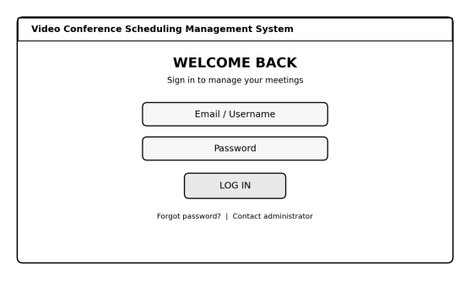
FIGURE 2.1: USER INTERFACE MODEL – LOGIN PAGE
The login page allows registered users to enter their email or username and password. The system checks the submitted credentials before allowing access to the dashboard. If the details are incorrect, an error message is displayed and the user is asked to try again.
2.2.2 Dashboard
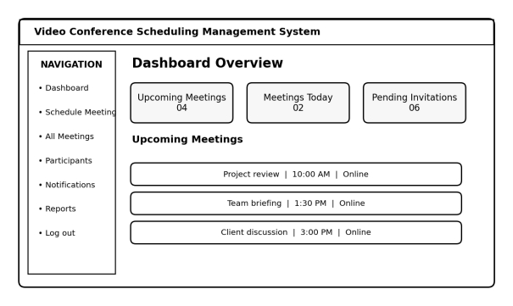
FIGURE 2.2: USER INTERFACE MODEL – DASHBOARD
The dashboard provides a summary of upcoming meetings, meetings scheduled for the current day, and pending invitations. It also provides navigation to the meeting schedule, participant records, notifications, reports where implemented, and logout. This screen helps users reach common functions quickly.
2.2.3 Meeting Scheduling Form
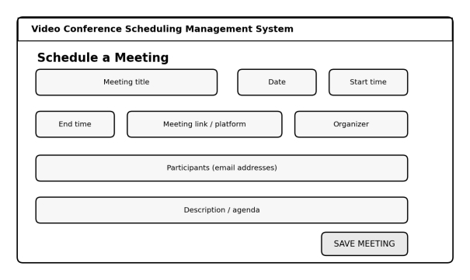
FIGURE 2.3: USER INTERFACE MODEL – MEETING SCHEDULING FORM
The meeting scheduling form enables a user to enter the meeting title, date, start time, end time, meeting platform or link, organizer, participants, and agenda. Before saving, the system checks whether the meeting details are complete and whether the proposed time overlaps with another meeting that the organizer has scheduled. The system should notify the user if a conflict is detected.
2.2.4 Meetings and Notifications
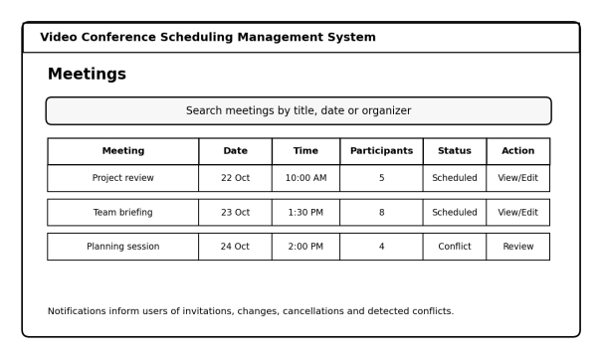
FIGURE 2.4: USER INTERFACE MODEL – MEETINGS AND STATUS
The meetings screen displays scheduled meetings and key details such as date, time, participants, and status. Users can open a meeting to view its details and, where permitted, edit or cancel it. Notifications are used to communicate invitations, schedule changes, cancellations, reminders, and detected conflicts.
2.3 Logic Models
Logic models describe the processes and relationships that control how the proposed system operates. They include the login process flowchart, system flowchart, data flow diagram, entity relationship diagram, use case diagram, and class diagram.
2.3.1 Login Process Flowchart
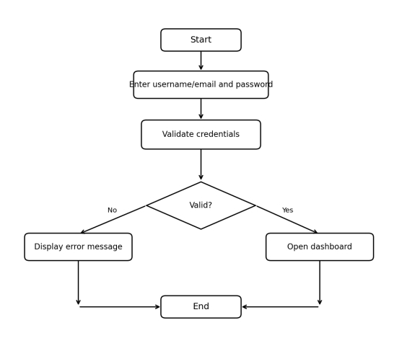
FIGURE 2.5: LOGIC MODEL – LOGIN PROCESS FLOWCHART
The login flowchart shows the steps followed when a user signs in. The user enters login details, and the system validates them against stored user information. If the details are valid, the dashboard is opened. If they are invalid, the system displays an error message and the user can try again.
2.3.2 System Flowchart
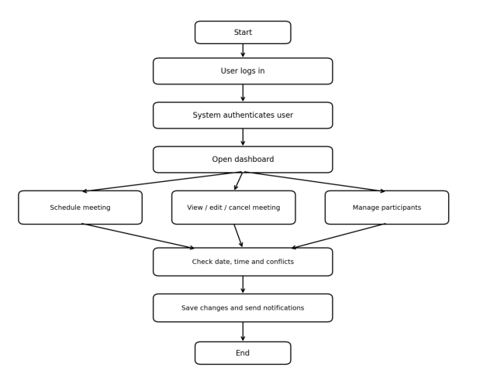
FIGURE 2.6: LOGIC MODEL – SYSTEM FLOWCHART
The system flowchart starts with user authentication and continues to the dashboard. The user can schedule a meeting, view or update existing meetings, or manage participants. The system checks meeting dates and times for possible conflicts, saves valid details, and sends notifications when required. The process ends when the user completes the required task or logs out.
2.3.3 Data Flow Diagram
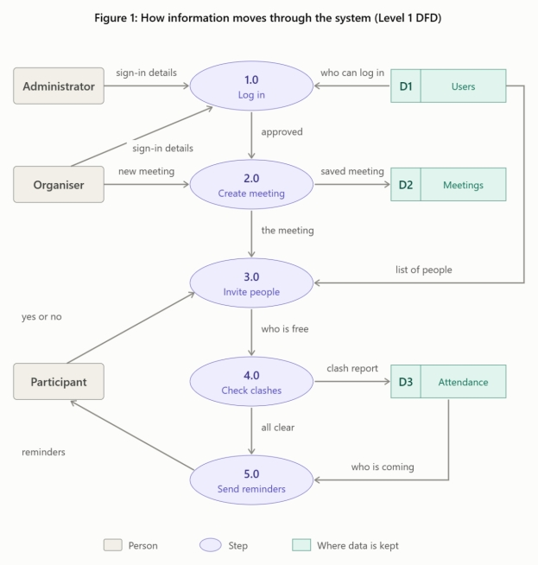
FIGURE 2.7: LOGIC MODEL – LEVEL 1 DATA FLOW DIAGRAM
The Level 1 Data Flow Diagram shows the main processes and data stores in the proposed system. The user supplies login details, meeting information, and participant details. The authentication process checks user records, while meeting management stores and retrieves meeting information. Conflict checking examines meeting schedules for overlapping times. The notification process prepares alerts related to invitations, changes, cancellations, or conflicts. The main data stores are Users, Meetings, Participants, and Notifications.
2.3.4 Entity Relationship Diagram
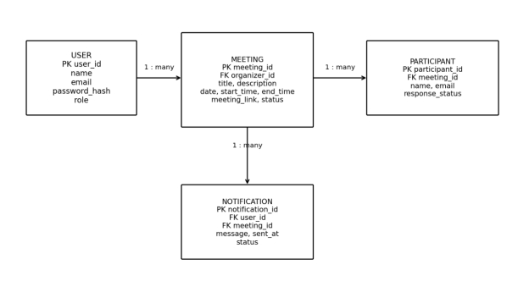
FIGURE 2.8: LOGIC MODEL – ENTITY RELATIONSHIP DIAGRAM
The Entity Relationship Diagram presents the proposed database entities and their relationships. The User entity stores account information. The Meeting entity stores the organizer, title, description, date, time, meeting link, and status. The Participant entity stores the people invited to a meeting and their response status. The Notification entity stores messages associated with users and meetings. Primary keys uniquely identify records, while foreign keys connect related records and help maintain data integrity.
2.3.5 Use Case Diagram
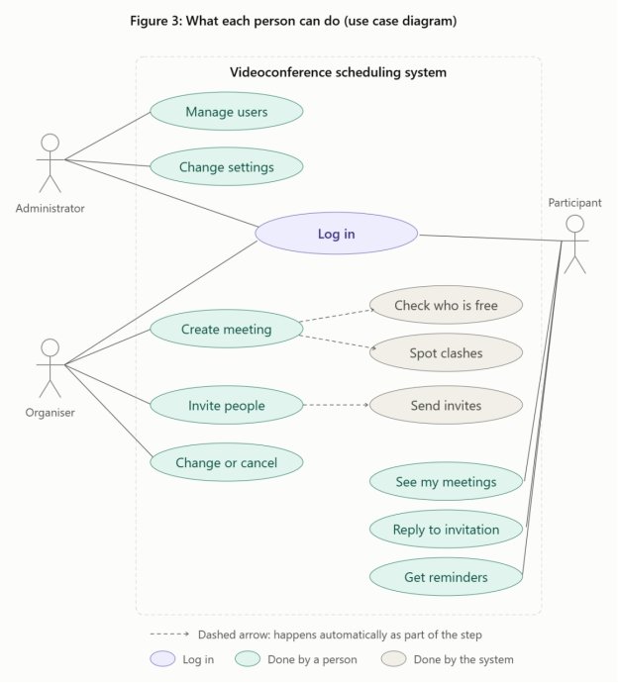
FIGURE 2.9: LOGIC MODEL – USE CASE DIAGRAM
The use case diagram illustrates the main functions available to a user or meeting organizer. These include logging in, viewing the dashboard, scheduling meetings, managing existing meetings, managing participants, checking conflicts, receiving notifications, viewing meeting details, and logging out. The diagram summarizes the interaction between the user and the system.
2.3.6 Class Diagram

FIGURE 2.10: LOGIC MODEL – CLASS DIAGRAM
The class diagram presents the main classes proposed for the system. The User class represents a registered user and supports login and meeting management. The Meeting class stores meeting details and supports creating, updating, cancelling, and checking for conflicts. The Participant class stores invitation and response information. The Notification class represents messages sent to users. The relationships show how users organize meetings, meetings contain participants, and notifications are associated with users and meetings.
2.4 Chapter Summary
This chapter has presented the proposed user interface and logic models for the Video Conference Scheduling Management System. The interface m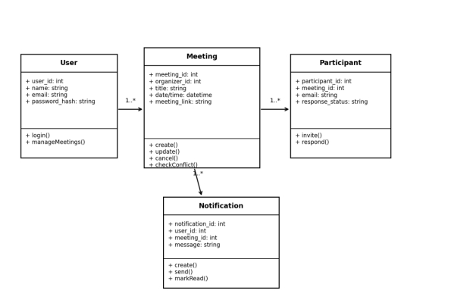Odels show the expected login, dashboard, meeting scheduling, and meeting management screens. The logic models describe authentication, the overall system process, data movement, database relationships, user interactions, and the main software classes. These models provide a design guide for the next stage of implementation using HTML, CSS, PHP, MySQL, and the XAMPP development environment.
CHAPTER THREE: SYSTEM IMPLEMENTATION
3.1 Introduction
This chapter describes the implementation of the Video Conference Scheduling Management System for VideoLink Enterprises, Nakuru. It explains how the system requirements and designs are translated into a web-based application for managing virtual meetings. The chapter covers the development of the user interface, implementation of the system logic, testing, and deployment. The proposed system is intended to improve the organisation of video conference meetings by supporting meeting scheduling, participant management, scheduling conflict detection, notifications, and reminders.
The technologies identified in the project proposal are PHP for server-side processing, MySQL for database management, HTML5 and CSS3 for page structure and presentation, and JavaScript for client-side interactivity. Apache is identified as the web server, while Visual Studio Code is used as the development environment. The implementation descriptions below are organised around the functions specified in the project proposal. Screenshots and actual test outcomes should be inserted after the corresponding features have been implemented and verified.
3.2 User Interface Development
The user interface provides the point of interaction between employees and the Video Conference Scheduling Management System. It is designed to make the main activities easy to access and understand. The interface supports secure access, viewing meeting information, creating and managing meetings, handling participants, and viewing notifications and reports.
3.2.1 Login Page Development
The login page provides registered users with access to the system. A user enters the required login credentials in the form provided. The system checks the submitted details against the user records stored in the database. A user with valid credentials is directed to the appropriate system area, while invalid credentials should produce an error message. Access to protected pages should be restricted to authenticated users.
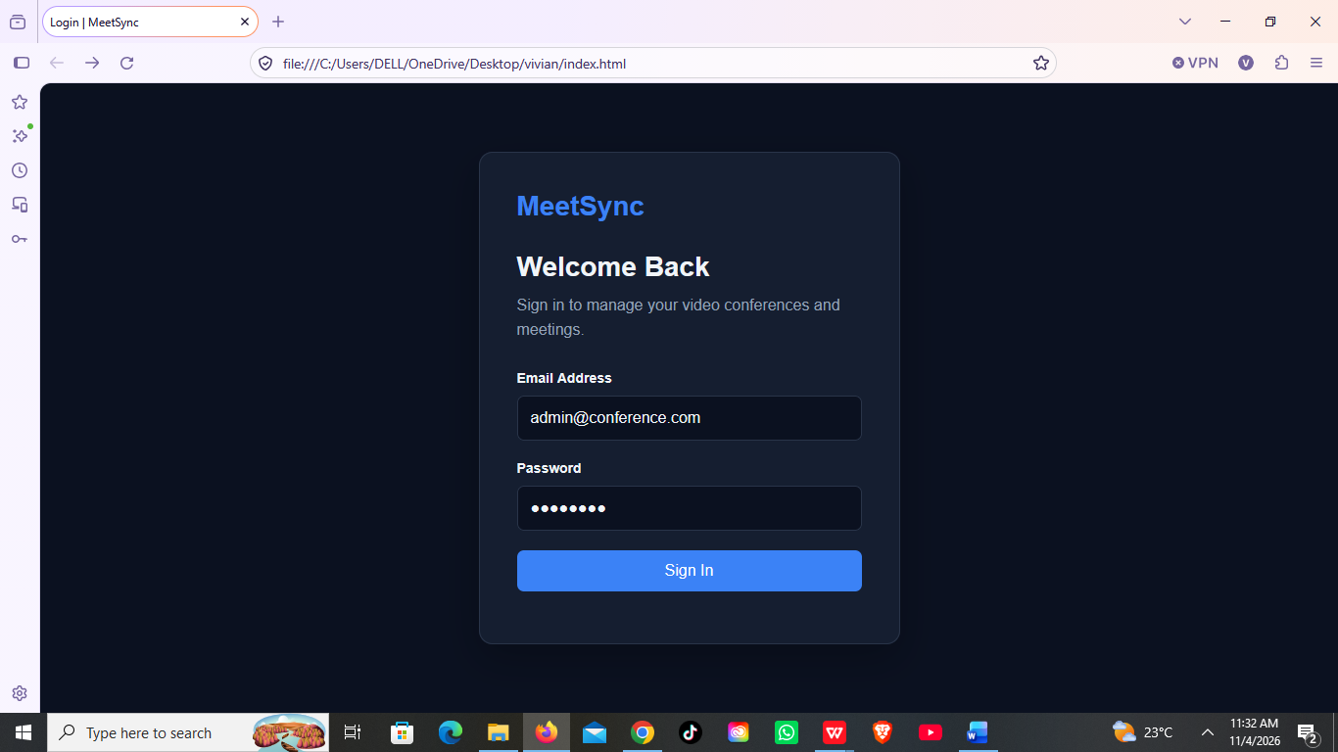
Figure 3.1: Login Page
3.2.2 Dashboard
The dashboard provides a summary of meeting activities after a user signs in. It is intended to display useful information such as upcoming meetings, meetings scheduled for the current day, pending invitations, and recent notifications. The dashboard also provides links to the main system functions so that users can quickly access meeting scheduling, participant management, calendars, and reports.
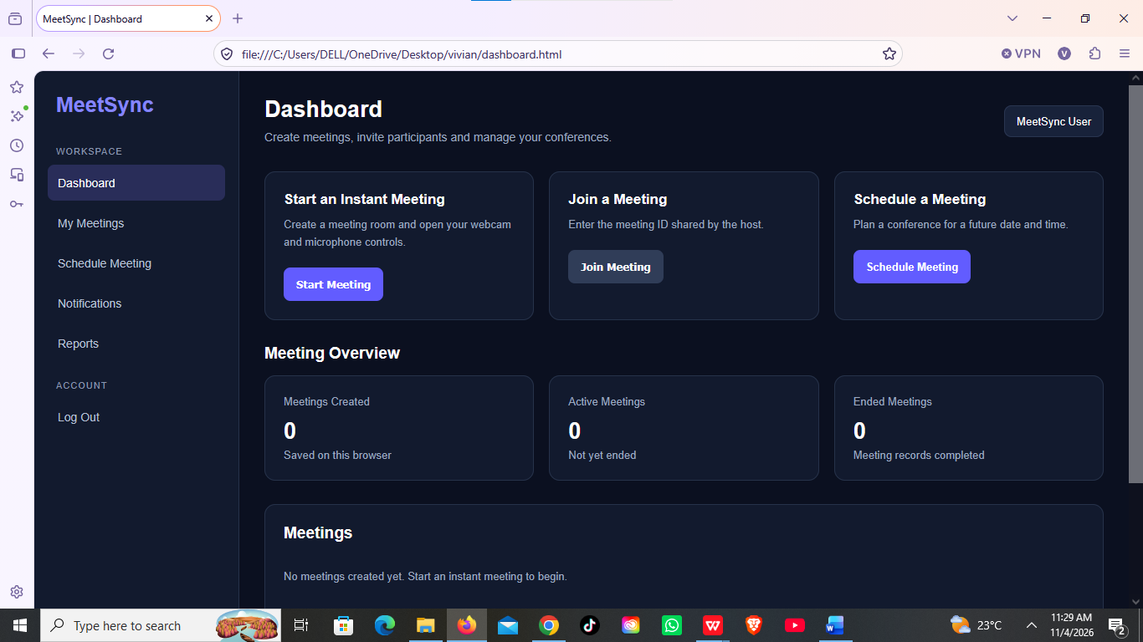
Figure 3.2: System Dashboard
3.2.3 Navigation Bar
The navigation bar provides links to the main sections of the application. These sections include the dashboard, meeting schedules, participants, calendar, notifications, reports, and administration functions where applicable. A consistent navigation structure helps users move between pages without having to return to the home page each time.
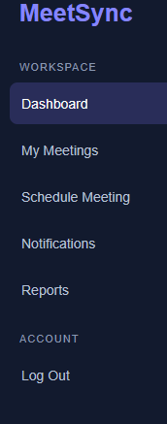
Figure 3.3: System Navigation Bar
3.2.4 Meeting Scheduling
The meeting scheduling page allows an authorised user to create a video conference meeting by entering details such as the meeting title, description or agenda, date, start time, duration, and invited participants. The page should validate required fields before submitting the information. Before a meeting is saved, the system is intended to check participant availability and identify overlapping meetings. Where a conflict is found, the user should be informed and prompted to select another available time.
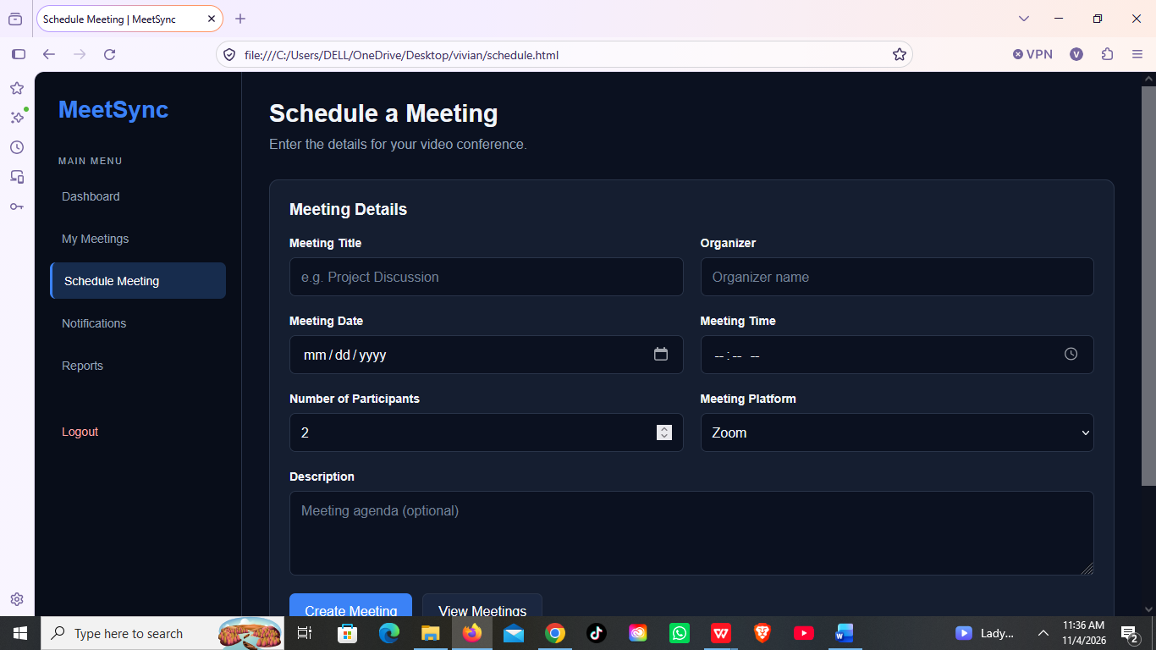
Figure 3.4: Meeting Scheduling Form
3.2.5 Participant Management
The participant management section stores and displays information about registered users who may be invited to meetings. A meeting organiser can select participants when creating or updating a meeting. Participants should be able to view invitations and confirm or decline attendance. The system should retain the response so that the organiser can monitor participation.
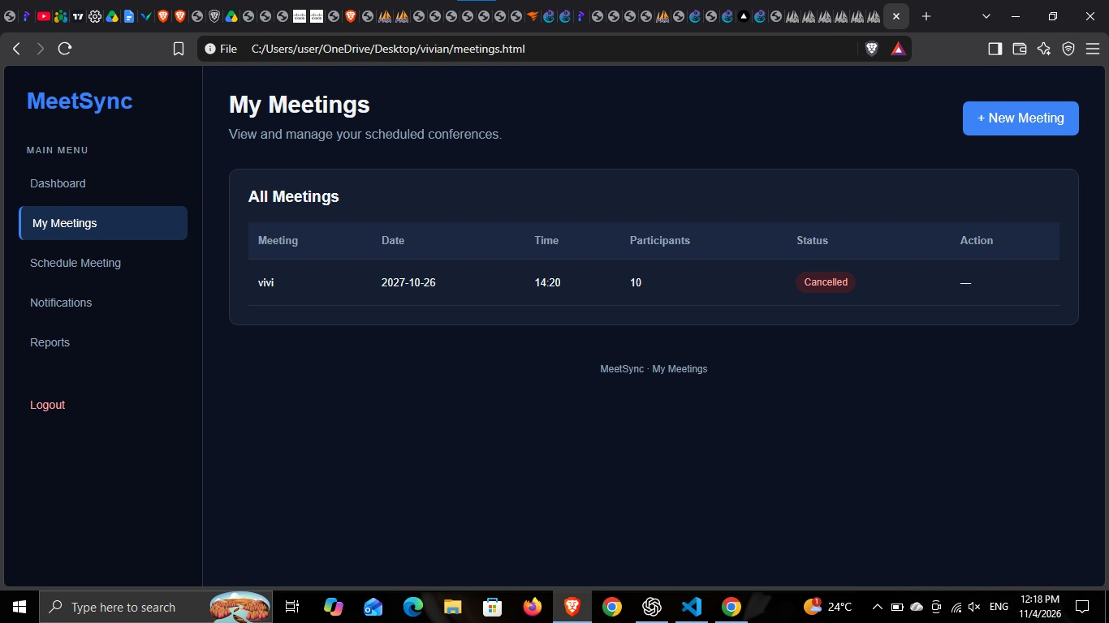
Figure 3.5: Participant Management Interface
3.2.6 Calendar, Notifications and Reminders
The calendar section presents scheduled meetings by date and time to support easier planning. The notifications section is intended to communicate new meeting invitations, changes to meeting details, cancellations, and upcoming meeting reminders. These features help ensure that participants receive relevant information in time and are aware of changes to their schedules.
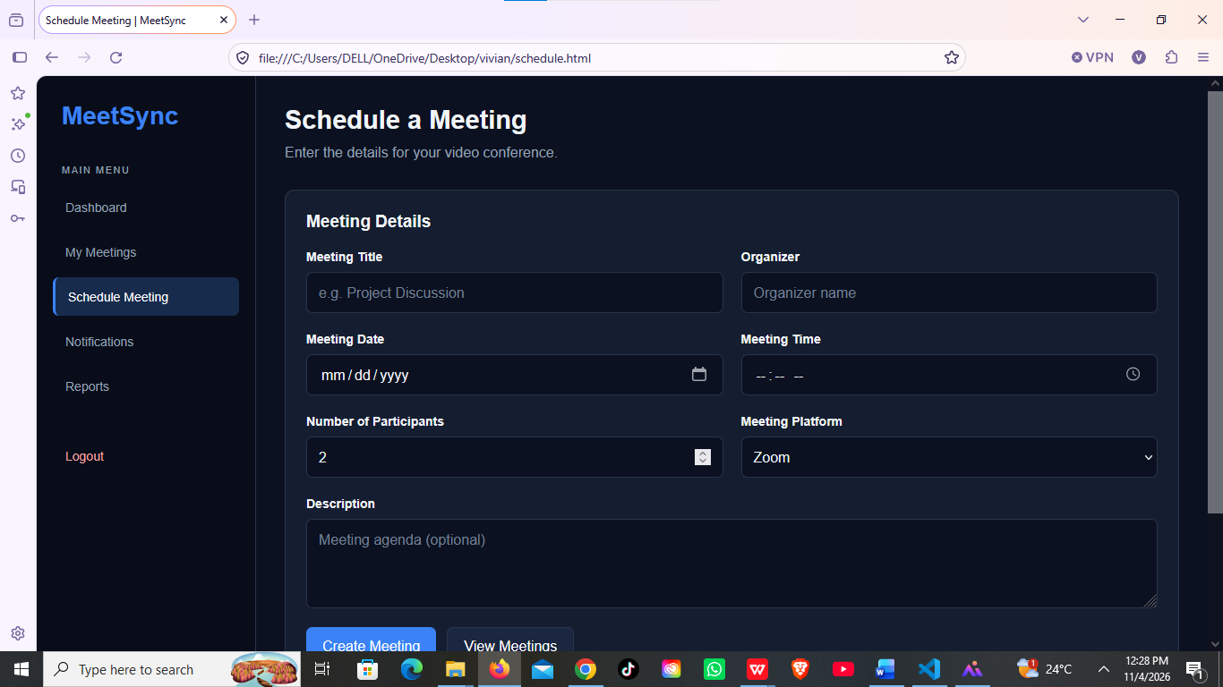
Figure 3.6: Calendar and Notifications Interface
3.2.7 Reports and Administration
The reports section is intended to provide summaries of meeting activity, participant attendance, and scheduling efficiency. Administrative functions support the management of user accounts and relevant system settings. Access to administrative functions should be limited according to the user's assigned role.
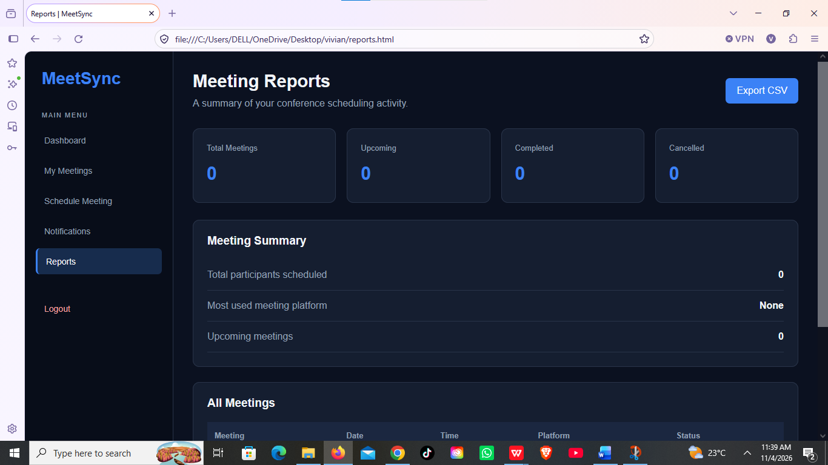
Figure 3.7: Reports and Administration Interface
3.3 Logic Development
Logic development describes the server-side operations that process user requests, apply system rules, and communicate with the MySQL database. PHP is specified for implementing the application logic, while MySQL stores user, meeting, participant, invitation, and notification records. The following subsections describe the main logic required by the system.
3.3.1 User Authentication and Access Control
When a user submits the login form, the application receives the credentials and checks them against the stored user account. If the details are valid, the system establishes an authenticated session and grants access to the pages permitted for that user. If the details are invalid, access is denied and an appropriate message is displayed. Role-based access control is intended to distinguish administrator, meeting scheduler, and participant permissions. Protected operations should verify the user's session and role before processing a request.
3.3.2 Meeting Scheduling and Conflict Detection
The meeting scheduling logic receives the meeting details submitted through the scheduling form. It validates the title, date, start time, duration, and selected participants before saving the meeting. The system then checks whether any selected participant has another meeting whose time overlaps the proposed meeting period. If an overlap is detected, the system should prevent the conflicting booking and display a warning. The system may then allow the organiser to choose a different time. If no conflict is detected, the meeting details are saved in the database.
3.3.3 Participant and Invitation Management
The participant management logic retrieves registered user records and associates selected participants with a meeting. It stores invitations and the responses received from participants, such as accepted or declined. This information enables the meeting organiser to view participant responses and plan meetings more effectively. The system should also ensure that only authorised users can modify meeting participants.
3.3.4 Notifications and Reminders
The notification logic creates alerts when a meeting invitation is issued or when meeting details are changed or cancelled. Reminder processing is intended to notify participants before the scheduled meeting. The system proposal identifies email and/or SMS as possible notification channels. The actual channel used should be confirmed during implementation, together with the required email or SMS service configuration.
3.3.5 Calendar, Reports and Administration
The calendar logic retrieves meetings from the database and arranges them according to their scheduled dates and times. The reporting logic summarises meeting activity, attendance, and scheduling information for display to authorised users. Administrative logic supports user management and system configuration. Database queries should be restricted according to the permissions of the logged-in user.
3.4 System Testing
System testing is carried out to determine whether the Video Conference Scheduling Management System performs according to its specified requirements. Testing should cover individual functions as well as the interaction between the user interface, PHP application logic, and MySQL database. The test cases below provide a framework for recording the actual results. The 'Actual Result/Status' column must be completed after each test has been performed; no test outcome is assumed in this document.
Test Area | Testing Action | Expected Result | Actual Result / Status
User login | Submit valid and invalid login credentials. | Valid users gain access; invalid credentials are rejected with an error message. | To be completed after testing.
Meeting creation | Create a meeting using complete and incomplete details. | Valid meeting details are saved; missing required details are identified. | To be completed after testing.
Conflict detection | Schedule two meetings for the same participant at overlapping times. | The system identifies the overlap and prevents the conflicting booking. | To be completed after testing.
Participant invitations | Invite participants and record their responses. | Invitations are associated with the meeting and responses are recorded. | To be completed after testing.
Notifications and reminders | Create or update a meeting and check the configured notification channel. | Relevant participants receive the appropriate notification or reminder. | To be completed after testing.
Calendar display | View meetings scheduled on different dates. | Meetings appear under the correct dates and times. | To be completed after testing.
Reports | Generate meeting activity and attendance summaries. | The system displays report information based on stored records. | To be completed after testing.
Access control | Attempt to access a restricted function using a user role without permission. | Unauthorised access is denied. | To be completed after testing.
After testing, any errors identified should be recorded, corrected, and tested again. The final documentation should include the actual result for each test case and brief details of any correction made.
3.5 System Deployment
System deployment involves preparing the completed application for use by VideoLink Enterprises. According to the project proposal, the application is intended to use PHP, MySQL, and the Apache web server. Deployment therefore requires configuring a suitable server environment, creating the required MySQL database, importing the database structure, configuring the application connection settings, and placing the application files in the web server's document directory.
Before the system is made available to users, the developer should verify that the application can connect to the database, that login and access permissions work correctly, and that the main meeting management functions operate as expected. User accounts should be configured securely, and users should be shown how to log in, schedule meetings, invite participants, respond to invitations, and view notifications and reports.
The project proposal does not identify a confirmed hosting provider, live system address, or completed deployment evidence. These details should be added after deployment has taken place.
[Insert a screenshot of the running system or its deployment environment here.]
Figure 3.8: Deployed Video Conference Scheduling Management System
Live system link: https://graceful-florentine-70d830.netlify.app

CHAPTER FOUR: CONCLUSION AND RECOMMENDATIONS
4.1. Conclusion
The aim of this project was to design and implement a Video Conference Scheduling Management System for VideoLink Enterprise in Nakuru. Chapter One discussed the problem of coordinating virtual meetings through separate emails, calls, messages and records, which leads to double-booked participants, missed updates and wasted time. It also set out the justification, objectives, functional requirements, tools and schedule for the project. Chapter Two presented the design of the system through user interface models, flowcharts, a data flow diagram, an entity relationship diagram, a use case diagram and a class diagram. Chapter Three described how these designs were implemented using HTML, CSS, JavaScript, PHP and MySQL, how the system was tested, and how it was deployed.
The system brings meeting scheduling into one place. Authorized users can create, view, update and cancel meetings, store meeting and participant information in a central database, have scheduling conflicts detected before a meeting is saved, and receive notifications and reminders. Role-based access gives administrators, organizers and participants only the functions they need, which protects information about users and meetings. The testing results in Section 3.4 show how well each of these objectives was achieved.
Through the project, valuable knowledge and skills were gained in system analysis, interface design, database design, PHP programming, integration, testing and documentation, and in applying them to a real coordination problem.
4.2. Recommendations
Although the system addresses the main scheduling problems described in Chapter One, several improvements can be made by future developers. The first is to send reminders and invitations by email and SMS, as well as within the system, so that users are informed even when they are not logged in. Integration with Google Calendar or Microsoft Outlook would let meetings appear in the calendars that people already use.
The system could also generate video conference links automatically through platforms such as Zoom or Google Meet, support recurring meetings, suggest the best meeting time based on the availability of all participants, and provide reports on meeting activity. A mobile application would make it easier to manage meetings on the go.
Finally, the organization should back up the database regularly, keep the hosting and PHP versions up to date, and consider adding two-step verification for administrator accounts to strengthen security.
REFERENCES
Elmasri, R., & Navathe, S. B. (2016). Fundamentals of database systems (7th ed.). Pearson.
Laudon, K. C., & Laudon, J. P. (2022). Management information systems: Managing the digital firm (17th ed.). Pearson Education.
Oracle Corporation. (n.d.). MySQL 8.0 reference manual. https://dev.mysql.com/doc/refman/8.0/en/
Sommerville, I. (2016). Software engineering (10th ed.). Pearson.
The PHP Group. (n.d.). PHP manual. https://www.php.net/manual/en/
Welling, L., & Thomson, L. (2016). PHP and MySQL web development (5th ed.). Addison-Wesley.

